Project Design Phase-II Technology Stack (Architecture & Stack)

|  |  |
| --- | --- |
| Team ID | PNT2022TMID10050 |
| Project Name | Personal Assistance for seniors who are  self- reliant |
| Maximum Marks | 4 Marks |

**Technical Architecture:**

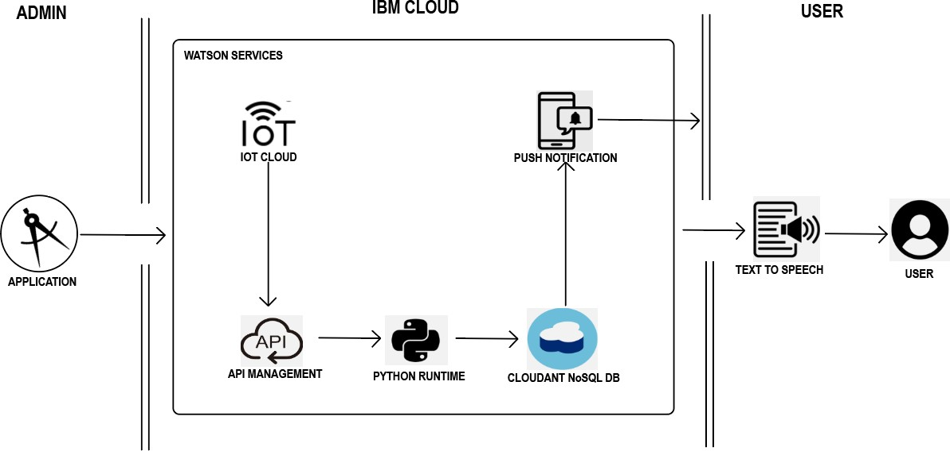

Table-1 : Components & Technologies:

|  |  |  |  |
| --- | --- | --- | --- |
| **S.No** | **Component** | **Description** | **Technology** |
| 1. | User Interface | Mobile App | HTML, CSS, JavaScript |
| 2. | Application Logic-1 | Mobile App to enter the Medicine details weekly | Python |
| 3. | Application Logic-2 | Gets the medication data from database | IBM Watson IOT API call data |
| 4. | Application Logic-3 | Converts the text to speech to pronunciation for the user | IBM Watson Assistant |
| 5. | Database | Medication time and tablets name on daily basis | MySQL |
| 6. | Cloud Database | Call the data IBM cloudant is used and user login credentials | IBM DB2, IBM Cloudant |
| 7. | File Storage | App code and IOT credentials are stored and API keys | IBM Block Storage |
| 8. | External API-1 | To get the medicine box status Open or  not | IBM box status API |
| 9. | External API-2 | To get the login credentials in IBMDB2 | Username and Password API |
| 10. | Machine Learning Model | To convert the text into speech for voice command the tablet details | Text to speech |
| 11. | Infrastructure (Server / Cloud) | To host the server and application | Cloud Foundry, Node Red |

Table-2: Application Characteristics:

|  |  |  |  |
| --- | --- | --- | --- |
| **S.No** | **Characteristics** | **Description** | **Technology** |
| 1. | Open-Source Frameworks | To develop the application interface, we use MIT App inventor. | MIT App inventor |
| 2. | Security Implementations | To secure the users login credentials and personal information. | SHA-256,OWASP |
| 3. | Scalable Architecture | To scale the application database | IBM auto scaling |
| 4. | Availability | To make use the application and data are available 24x7 | IBM Cloud load balancer |
| 5. | Performance | To increase the performance of the application hosted in the high- performance instance. | IBM instance |